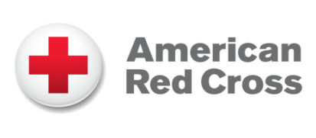 **American Red Cross Brief Descriptions**

For Workplace Giving Campaign Communications

**25-Word Description:**

The American Red Cross prevents and alleviates human suffering in the face of emergencies by mobilizing the power of volunteers and the generosity of donors.

**50-Word Description:**

The American Red Cross prevents and alleviates human suffering in the face of emergencies by mobilizing the power of volunteers and the generosity of donors. Survivors of disasters, patients needing lifesaving blood, members of the military and many more turn to the Red Cross every second of every day.

**150-Word Description:**

The American Red Cross prevents and alleviates human suffering in the face of emergencies by mobilizing the power of volunteers and the generosity of donors. As the nation’s premier emergency preparedness and response organization, the Red Cross is there to help and comfort people through devastating crises — from home fires to earthquakes and much more. Families in the aftermath of disasters, patients needing lifesaving blood, members of the military and many others turn to the Red Cross every second of every day. With about 230 chapters across the U.S., we have a presence in every community. Alongside our global Red Cross partners, we are part of the largest humanitarian network in the world. For more than 140 years, the American Red Cross has been helping neighbors down the street, across the country and around the world. Join us today by making a donation, volunteering, giving blood or taking a class.