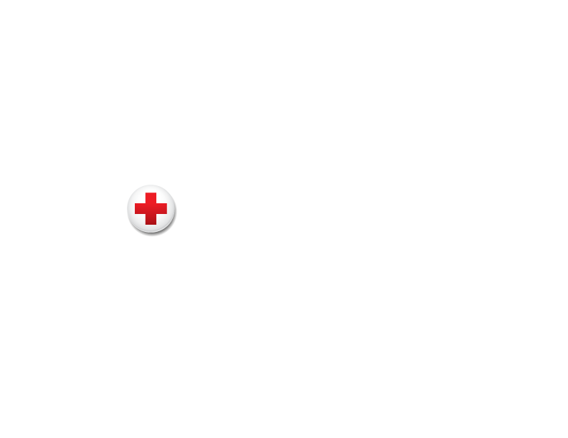
ADGP $1 Million Member
Membership Resources
Digital Engagement Toolkit

Thank you for being a $1M member of the American Red Cross Annual Disaster Giving Program. We have created a new suite of digital resources specially for our members to showcase their support to your stakeholders. Below you will find templated communication resources to share with your employees, on social media and with other stakeholders.

Thank you for your steadfast support of the American Red Cross mission — we could not provide help and hope to survivors of disasters without generous ADGP members like you.

Resources included:

Page | Resource
2 | A Leadership Thank You message and mission photo from Gail McGovern, President and CEO for your use internally
3 | Select photos and videos showing the Red Cross mission in action
4 | Program recognition badges to showcase your support on your website, intranet or social media
5 | Digital web banners for your use on your website, intranet or Red Cross microsite
6 | Social post templates to use throughout the year and during times of disaster
9 | Preparedness resources to share with your employees and other stakeholders
10 | Employee messaging templates to help employees impacted by disaster and for those who want to help

Please note, you must have a current partnership agreement in place to utilize Red Cross photos and/or logo. Additionally, you must include our non-endorsement statement* on materials where our assets are displayed (websites, print materials, videos, etc.). For more information, please consult your relationship manager.

*The American Red Cross name, logo and copyrighted materials are used with its permission, which in no way constitutes an endorsement, express or implied, of any product, service, company, opinion or political position. The American Red Cross name and logo are registered trademarks owned by the American National Red Cross. For more information about the American Red Cross, please visit redcross.org.
Leadership Thank You Message

Share the following message from Gail McGovern, President and CEO, with your internal audience, via email or on your intranet.

This quote is for internal use only. For a quote to share on your external channels, please contact your relationship manager.

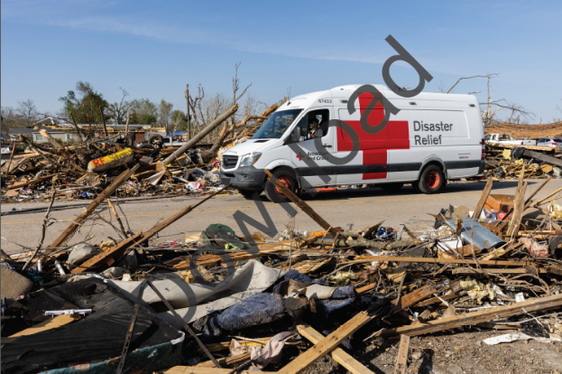
We are so grateful to [Company] and your employees for your generous commitment to help provide disaster relief for those in need across the country as a member of the American Red Cross Annual Disaster Giving Program (ADGP).

As we continue to see the devastating impact of stronger and more frequent disasters, we’re so honored to count [Company] as a valued member of the program. ADGP members are truly unique because their generous contributions in advance of disasters allow us to prepare for emergencies nationwide and to grow our capacity to respond immediately with food, shelter and care for those who need it most.

Donations from companies like [Company] power our response to disasters both big and small — from hurricanes and floods to home fires and tornadoes — ensuring Red Cross teams are resourced and ready to respond as soon as we’re needed.

Our disaster relief work wouldn’t be possible without your support. Thank you for your compassion and dedication to our lifesaving mission.

Gail McGovern, President and CEO
Mission Photos and Videos*

Please view the specially curated photos and videos that you can share with your employees or externally. Experience the mission through volunteers and clients.

Videos you can share linked below. Check out Vimeo for additional videos.
- We are the Red Cross
- The American Red Cross Responds to the Climate Crisis
- Prepare with the American Red Cross Emergency App
- Ty and his Family after Mississippi Tornadoes
Click on any thumbnail below to download a high-resolution image (ctrl + click). Or click here to download.

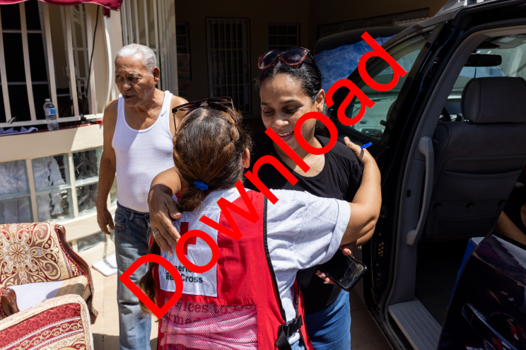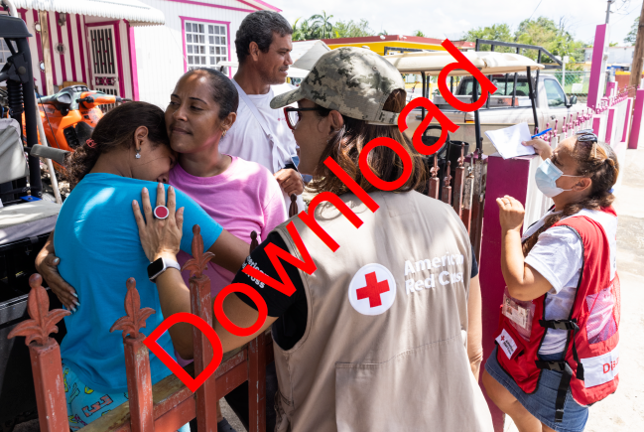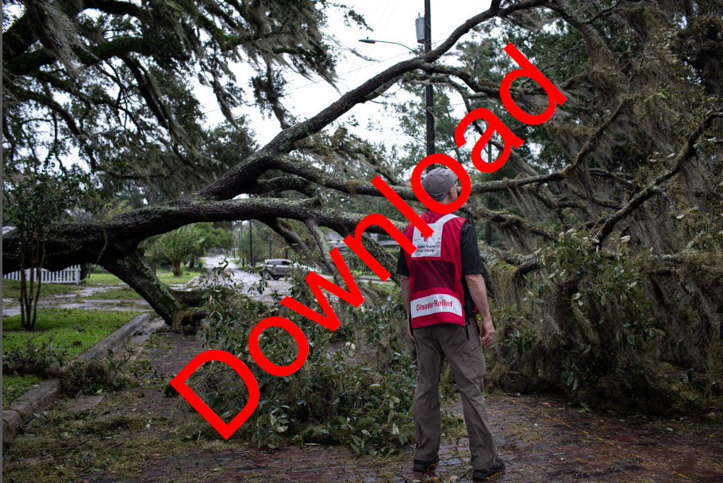

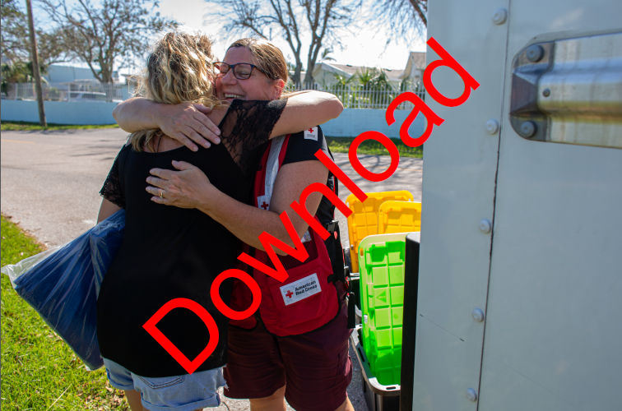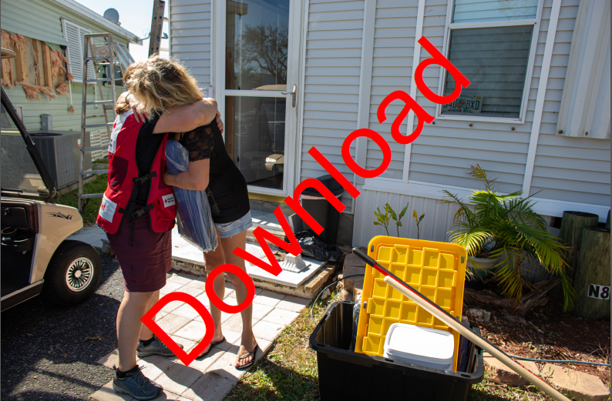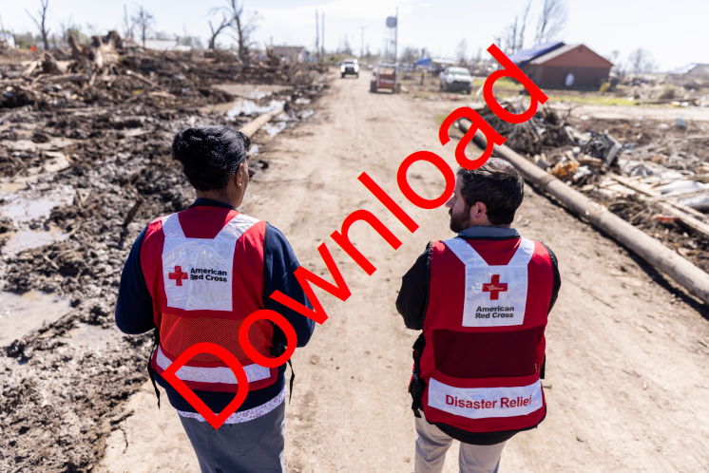

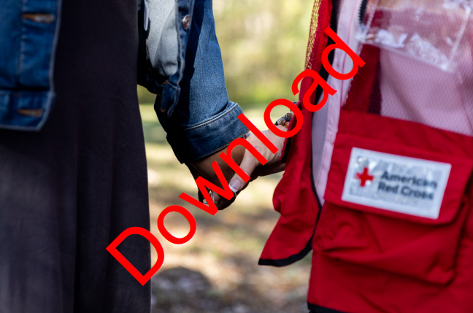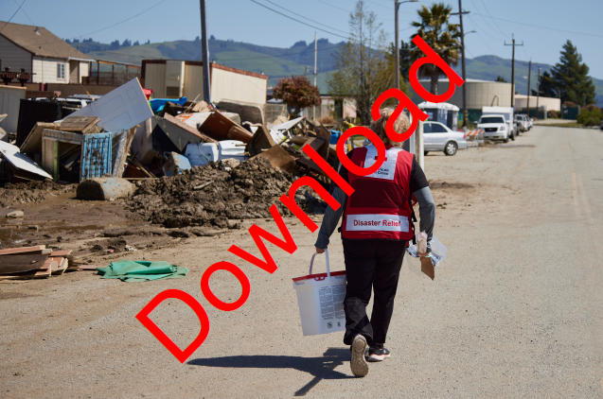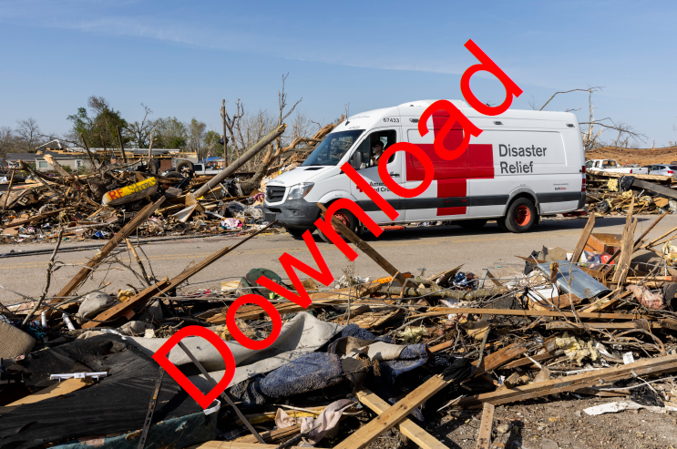

* You are responsible for how this photo is used and that the usage is appropriate, accurate, truthful and not misleading, both in whole and in part. Do not manipulate, alter or distort any photo. Please credit the American Red Cross where appropriate.

Social Media Badges

Show your partnership with the Red Cross by displaying the ADGP $1M partner badge on your social media accounts.

Recommended locations for badge:
- Red Cross microsite (work with your relationship manager to post)
- Social media accounts
- Company intranet
- Company website
- Badges can link to your giving microsite, redcross.org, or redcross.org/donate

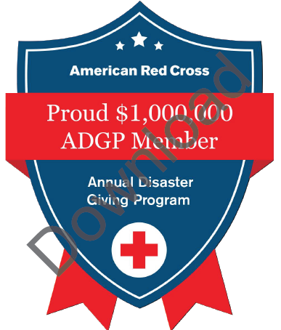

Click here to download the file

Digital Web Banners

Add special ADGP web banners to your company’s web page or intranet to show your partnership with the Red Cross to employees, partners and customers.

Recommended locations for banner:
- Red Cross microsite (work with your relationship manager to create a giving microsite or update with badge)
- Company intranet
- Company website
- Badges can link to your giving microsite, redcross.org, or redcross.org/donate

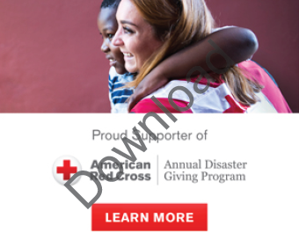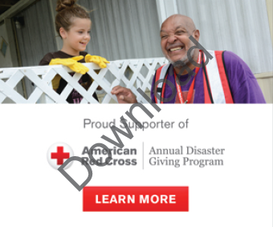





Social Post Templates

Share these messages on your company’s social media to promote your disaster relief support.

The posts tag the American Red Cross on Twitter, but we encourage you to personalize these messages and tag: American Red Cross on Facebook; @RedCross on Twitter; @AmericanRedCross on Instagram; American Red Cross on LinkedIn; @americanredcross on TikTok; or @americanredcross on Threads.

You may also retweet or share any relevant posts from our national accounts.

General Disaster Relief
- Our disaster relief partner, the @RedCross, responds to 60k+ disasters each year. ⛑ We’re proud to support their work helping communities across the country impacted by disasters big and small. Learn more about our partnership with the Red Cross: [company page]
- As a proud member of the @RedCross [Annual Disaster Giving Program], we’re honored to help the organization prepare for, respond to and help people recover from disasters big and small. ❤️ Join us to support their lifesaving mission today: https://www.redcross.org/donate
- Did you know that our partner, the @RedCross, responds to a disaster every 8 minutes? Emergencies can happen anytime and anywhere. Make sure you’re prepared: https://www.redcross.org/preparedness

- Do you have a plan if disaster strikes? Our disaster relief partner, the @RedCross, has free apps to help your family be prepared and stay informed if disaster strikes. 📱Download one today! http://rdcrss.org/apps

Click here to download graphics below.

 | 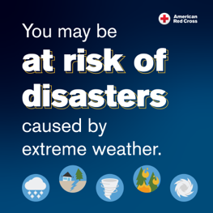 |  | 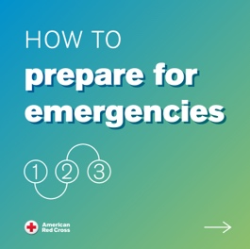 |  |  |  | 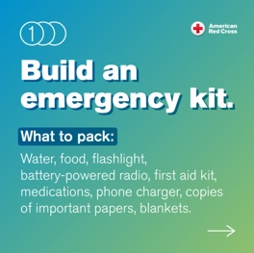 |  |  | 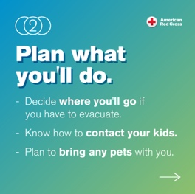 |  |  | 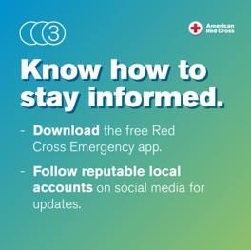
 | Extreme Weather  Also provided as Vertical size | Red Cross Prep  Emergency Plan 1 |  |  |  | Red Cross Prep  Emergency Plan 2 |  |  | Red Cross Prep  Emergency Plan 3 |  |  | Red Cross Prep  Emergency Plan 4
 | 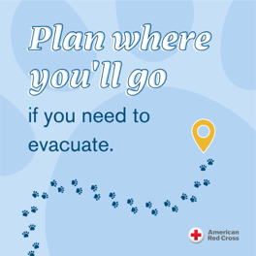 | 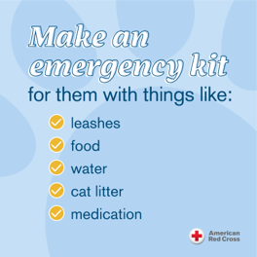 |  |  |  | 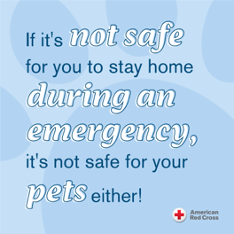 |  |  | 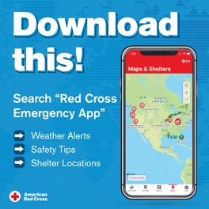 |  |  | 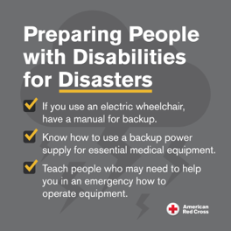
 | Red Cross Prep  Plan with Pets |  |  |  | Red Cross Prep  Kit for Pets |  |  | Red Cross Prep  Pet Safety |  |  | Red Cross Prep  Emergency App (also provided as  Vertical size) |  |  | Red Cross Prep  Preparing People with Disabilities (also provided as Vertical size)

Disaster Relief Posts with Climate Messaging
- 🌀🔥 Disasters are increasing in frequency and intensity across the country. Do you have a plan if a disaster strikes? Check out these tips from our disaster relief partner, the @RedCross, to help keep your family safe: https://www.redcross.org/preparedness
- As a proud member of the @RedCross [Annual Disaster Giving Program], we know our support is more important than ever as we experience more frequent and intense disasters due to the climate crisis. Join us to support their lifesaving mission today: https://www.redcross.org/donate
- The number of billion-dollar disasters in the U.S. has increased by 70% over the last decade. Our disaster relief partner, the @RedCross, counts on our support to help people prepare for, respond to & recover from disasters big & small. ⛑ Learn more: [company page]
- Communities are experiencing more frequent and intense disasters brought on by the climate crisis. Are you prepared? Our disaster relief partner, the @RedCross, has free apps to help your family stay informed if disaster strikes. 📱Download one today! http://rdcrss.org/apps
- The changing climate is a humanitarian crisis that impacts everyone. As a proud @RedCross Annual Disaster Giving Program member, [COMPANY] is supporting urgent actions to help families and communities across the country as their needs grow in the wake of increasingly frequent and intense disasters. Learn how you can stand with survivors: redcross.org/ClimateCrisis #ClimateCrisis

- For use with Image 13391-005.jpg:
Within a five-month period, California experienced more than 30 atmospheric rivers, causing record-setting rainfall, snow and devastating floods across the state.

The climate crisis is causing more intense and frequent storms, significantly impacting communities and increasing the need for critical aid and assistance.

We are grateful to partner with the @redcross as an [Annual Disaster Giving Program] member to support their vital work in communities across the country reeling from the impacts of devastating disasters. Learn more about our partnership with the Red Cross: [company page]

Click here to download graphics/photo below.
 | 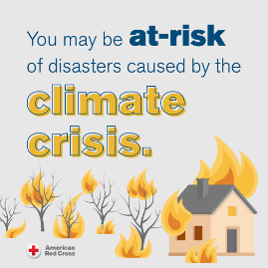
 | Climate Crisis Disasters  (Also provided as vertical size) | Extreme Weather  (Also provided as Vertical size) |  | Red Cross Prep  Emergency App (also provided as  Vertical size) | Red Cross Prep  Preparing People with Disabilities (also provided as Vertical size)
 | 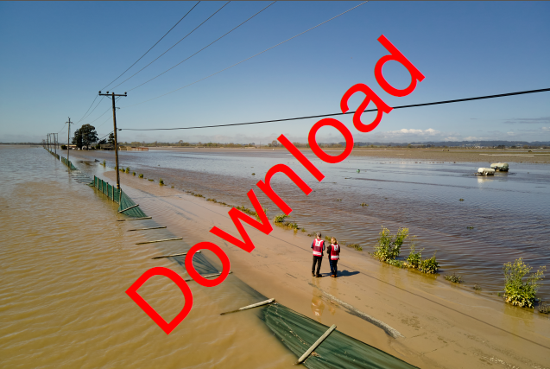 |  |  | 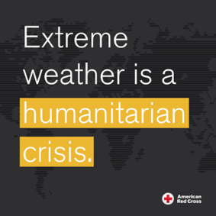
 | 13391-005.jpg |  |  | Red Cross Climate Crisis

Episodic Disaster Templates [only for use when there is an open designation for a current disaster on redcross.org. Please reach out to your relationship manager for more information.]
- We are devastated by the destruction caused by [current disaster]. 💔 We stand with our disaster relief partner, the @RedCross, as they provide help, comfort and hope to those impacted. Join us by making a gift today: https://www.redcross.org/donate
- As a proud member of the [Annual Disaster Giving Program], we’re honored to support our disaster relief partner, the @RedCross, as volunteers deploy to help in the aftermath of [current disaster]. ⛑ Join us to support their efforts: https://www.redcross.org/donate
- As impacted communities begin the road to recovery in the wake of [current disaster], we’re proud to support @RedCross relief efforts. As an American Red Cross [Annual Disaster Giving Program] member, we encourage you to help! Make a gift today: https://www.redcross.org/donate

Preparedness Messaging for Employees
Share the message below with employees via email or post on your intranet to help them prepare for disasters.

If you would like more specific information to share with your employees at key times of year (e.g. hurricane season, National Preparedness Month), including social posts and employee communication templates, please visit the ADGP Membership Hub.

Disasters can happen at any time — that’s why it’s essential that you and your family are prepared. Our partner, the American Red Cross, encourages you to take these three simple steps to ensure you know what to do if the unthinkable happens:

- Get a Kit. Build your emergency kit with a gallon of water per person, per day, non-perishable food, a flashlight and a battery-powered radio. Also include a first aid kit, medications, supplies for infants or pets, a multi-purpose tool and personal hygiene items. Don’t forget to add copies of important papers, cell phone chargers, blankets, maps of your area and emergency contact information.

- Make a Plan. Do you know what to do if you are separated from your family during an emergency or what to do if you have to evacuate? If not, make a plan today that takes into account your child’s school, any pets in your household, your work and your community’s emergency plans.

- Be Informed. Plan to stay informed by finding out how local officials will contact you during a disaster and how you will get important information, such as evacuation orders.

You can also download the free Red Cross Emergency app for expert tips and useful tools to help keep you and your family safe during a disaster. To learn more, visit redcross.org.

Based on where you live, it’s essential to be prepared for disasters that occur most frequently in your area. To learn more about how to get ready for different types of disasters, please visit the following links.

Hurricane Safety Tips
Wildfire Safety Tips
Home Fire Safety Tips
Flood Safety Tips
Heat Wave Safety Tips
Tornado Safety Tips

Getting Help for Employees
Use the below template and share with employees who may need assistance or resources during a disaster.

[Insert message about current disaster]

As a proud member of the American Red Cross Annual Disaster Giving Program (ADGP), since DATE, COMPANY has made an annual contribution to the Red Cross in advance of disasters, powering the organization with strong infrastructure, innovative technology and critical resources necessary to provide relief and support to those in crisis. This pre-investment ensures the Red Cross is prepared to meet the urgent needs of people affected by disasters big and small, anytime and anywhere across the U.S. As a COMPANY employee, you are part of these efforts, too, and we want to thank you for helping all of us be there for individuals and families in their times of greatest need.

Our hearts are with all our employees who have been impacted by [Disaster]. If you have been impacted, the resources below are available to you to get help. We know that many of you have asked how you, too, can help. Below are some ways that you can channel your generosity at this time.

How You Can Get Help
- If you are in immediate need of help, please contact your local Red Cross or find an open shelter. You can also call 1-800-RED CROSS for assistance.

- Find shelter if you need to leave your home due to a disaster or emergency, for a safe place to stay, food, water, basic health and emotional services and more.

- Download the Red Cross Emergency App for real time access to shelter locations, weather alerts, preparedness information and safety tips.

- Take the first steps after an emergency with Red Cross recovery resources.
Best Ways to Help
- Make a Financial Donation. After a disaster, financial donations are the quickest way to help people in need. If you’re able, please make a gift to support disaster relief here [Company microsite, if one or redcross.org/donate].

- Give Blood. The Red Cross depends on volunteer blood donors for lifesaving blood each and every day — not only following disasters. You can schedule a blood donation appointment at RedCrossBlood.org.

- Volunteer. Volunteers carry out 90% of the work of the Red Cross. We are always looking for more trained volunteers to help with sheltering, health services and other urgent needs. Learn more about their most needed positions and sign up by visiting redcross.org/volunteertoday.

