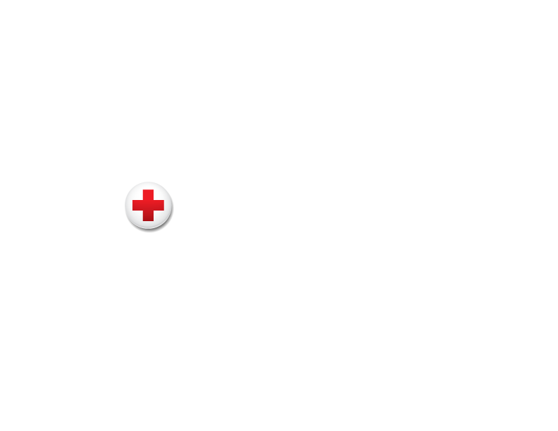

Membership Resources

**Annual Disaster Giving Program Communications Resources: Suggested Social Media Posts**

Engage followers and fans in your partnership and follow the American Red Cross social media accounts to get the most up-to-date information on our work. The below posts tag the [@RedCross](https://twitter.com/redcross) on X, but we encourage you to personalize these messages and tag us on other platforms as well.

* + [X](https://www.twitter.com/redcross)
  + [Facebook](https://www.facebook.com/redcross)
  + [Instagram](https://www.instagram.com/americanredcross/)
  + [LinkedIn](http://www.linkedin.com/company/american-red-cross)
  + [YouTube](http://www.youtube.com/amredcross)
  + [Threads](https://www.threads.net/@americanredcross)
  + [TikTok](https://www.tiktok.com/@americanredcross?lang=en)

Feel free to comment on Red Cross posts to share how the subject has affected your community, why it’s important and if your company is involved.

**Template Messages to Launch Your Partnership**

* We’ve joined the American Red Cross Annual Disaster Giving Program, helping ensure the @RedCross has vital resources to prepare for and respond to disasters big and small across the country, anytime and anywhere. Learn more *[LINK TO ANNOUNCEMENT RELEASE]*
* We’re proud to join the @RedCross Annual Disaster Giving Program, helping the organization respond immediately wherever it is needed, day or night *[LINK TO ANNOUNCEMENT RELEASE]*

**Ongoing Template Messages**

* As a @RedCross disaster relief partner, we help the organization respond to more than 65,000 disasters a year. Learn more about how you can help, too: [http://rdcrss.org](http://rdcrss.org/)
* When preparing for disasters, our partner the @RedCross reminds you to make a plan! <http://rdcrss.org/prepare>
* Download the free Emergency App from our disaster relief partner the @RedCross for instant access to preparedness tips and weather alerts for your area: <http://rdcrss.org/apps>
* Tips like these can help prevent home fires. Learn more from our disaster relief partner @RedCross: <https://www.redcross.org/fire> #EndHomeFires