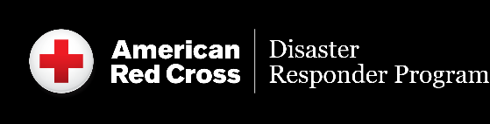
Membership Resources

Disaster Responder Program Member

Communications Resources:

Suggested Social Media Posts

Engage followers and fans in your partnership and follow the American Red Cross social media accounts to get the most up-to-date information on our work. The below posts tag the @RedCross on X, but we encourage you to personalize these messages and tag us on other platforms as well.

  - Facebook
  - Instagram
  - LinkedIn
  - X
  - YouTube
  - Threads
  - TikTok

Feel free to comment on Red Cross posts to share how the subject has affected your community, why it’s important and if your company is involved.

Template Messages to Launch Your Partnership
- We’ve joined the American Red Cross Disaster Responder Program, helping ensure the @RedCross has vital resources to prepare for and respond to disasters big and small across the country, anytime and anywhere. Learn more [LINK TO ANNOUNCEMENT RELEASE]
- We’re proud to join the @RedCross Disaster Responder Program, helping the organization respond immediately wherever it is needed, day or night [LINK TO ANNOUNCEMENT RELEASE]

Ongoing Template Messages
- As a @RedCross disaster relief partner, we help the organization respond to more than 65,000 disasters a year. Learn more about how you can help, too: http://rdcrss.org
- When preparing for disasters, our partner the @RedCross reminds you to make a plan! http://rdcrss.org/prepare
- Download the free Emergency App from our disaster relief partner the @RedCross for instant access to preparedness tips and weather alerts for your area: http://rdcrss.org/apps
- Tips like these can help prevent home fires. Learn more from our disaster relief partner @RedCross: https://www.redcross.org/fire #EndHomeFires

