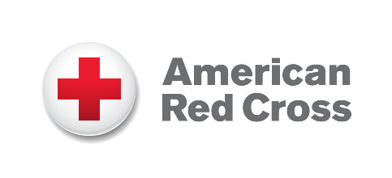
[City, State] — [Date]
Organization Comms Contact INSERT COMPANY LOGO

FOR IMMEDIATE RELEASE
[Company Name] Announces New Partnership with the American Red Cross to Support Humanitarian Relief Efforts
[Date, City] — [Company Name] today announced its commitment to support the American Red Cross through [describe donation: financial contribution, employee engagement, etc.]. This partnership strengthens ongoing efforts to help communities prepare for, respond to, and recover from disasters across the country.
The American Red Cross provides lifesaving services every day, from disaster relief and blood collection to support for military families and health and safety training. By joining this mission, [Company Name] aims to advance humanitarian work that brings comfort, care, and hope to people facing their most difficult moments.
“Insert quote from company representative about why they chose to support the Red Cross, their commitment to philanthropy, and the importance of strengthening communities.” — [Name, Title, Company]
Through this commitment, [Company Name] will help ensure the Red Cross can continue delivering critical aid when it’s needed most, whether responding to home fires, large-scale disasters, or urgent community needs.
About [Company Name]
Insert company boilerplate.
About the American Red Cross:
The American Red Cross shelters, feeds and provides comfort to victims of disasters; supplies about 40% of the nation’s blood; teaches skills that save lives; distributes international humanitarian aid; and supports veterans, military members and their families. The Red Cross is a nonprofit organization that depends on volunteers and the generosity of the American public to deliver its mission. For more information, please visit redcross.org or CruzRojaAmericana.org, or follow us on social media.

###

