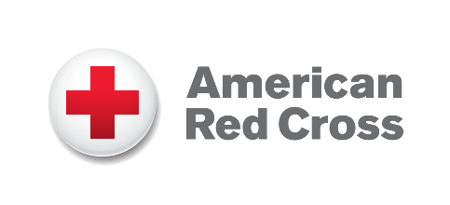
[City, State] — [Date]
Organization Comms Contact INSERT COMPANY LOGO

[Company Name] Renews Support for the American Red Cross, Strengthening Ongoing Humanitarian Partnership
[Date, City] — [Company Name] announced the renewal of its partnership with the American Red Cross, reaffirming its dedication to helping communities in times of crisis. This renewed commitment includes [describe renewed donation or expanded support], building on the company’s previous contributions to disaster relief and community resilience.
Over the past year, the Red Cross has responded to thousands of disasters and provided year-round support through blood collection, health and safety training, services for military families, and global humanitarian assistance. [Company Name]’s continued support helps ensure these essential services remain available whenever and wherever they are needed.
“Insert quote from company representative highlighting why they chose to recommit, the impact they’ve seen from the partnership, and their ongoing dedication to philanthropy and community well-being.” — [Name, Title, Company]
With this renewed partnership, [Company Name] reinforces its belief in the power of humanitarian action and its commitment to helping the Red Cross deliver hope and relief to people facing emergencies every day.
About [Company Name]
Insert company boilerplate.
About the American Red Cross:
The American Red Cross shelters, feeds and provides comfort to victims of disasters; supplies about 40% of the nation’s blood; teaches skills that save lives; distributes international humanitarian aid; and supports veterans, military members and their families. The Red Cross is a nonprofit organization that depends on volunteers and the generosity of the American public to deliver its mission. For more information, please visit redcross.org or CruzRojaAmericana.org, or follow us on social media.

###

