**Sample Language for your Website**

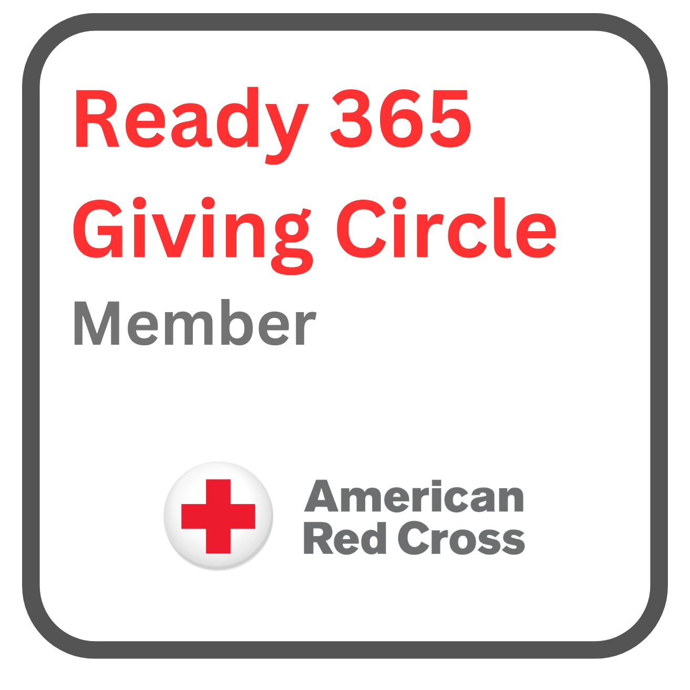

As a proud member of the Ready 365 Giving Circle program, (Insert Partner Name) stands alongside the American Red Cross and its dedicated army of volunteers to bring help and hope when people need it most.

Nearly every second of every day, the American Red Cross is caring for others by providing essential services including:

* Emergency financial assistance, food, and shelter to survivors affected by various disasters, ranging from hurricanes to home fires.
* Supplying life-saving blood to patients in need.
* Offering round-the-clock support to service members, veterans, and their families.
* Providing comprehensive training and education in CPR, First Aid, AED, water safety, and more.

To learn more about their impactful and lifesaving work, please visit [redcross.org](https://www.redcross.org/). Together, let's make a difference and support those who need it most.