Social Media Toolkit

The American Red Cross would like to engage with you on social media! Below you will find information regarding our social media accounts and ways to engage your followers. Please contact your relationship manager with any questions.

Engage with Us!
- Like our American Red Cross Facebook and Instagram pages and follow us on X in order to get the most up-to-date information on our work.

- You may tag the Red Cross and/or refer to our accounts below:

  - Regional Accounts
    - X: twitter.com/CTRedCross or twitter.com/RIRedCross
    - Facebook: facebook.com/CTRedCross or facebook.com/RIRedCross
    - Instagram: instagram.com/RedCrossCT or instagram.com/RIRedCross

  - National Accounts:
    - X: twitter.com/redcross
    - Facebook: facebook.com/redcross
    - Instagram: instagram.com/americanredcross
    - TikTok: https://www.tiktok.com/@americanredcross
    - LinkedIn: linkedin.com/company/american-red-cross/mycompany/
    - Blog: redcrosschat.org

- Please give your social media information to your relationship manager so that our local accounts can follow your organization as well.

Template Messages
- New Partnership
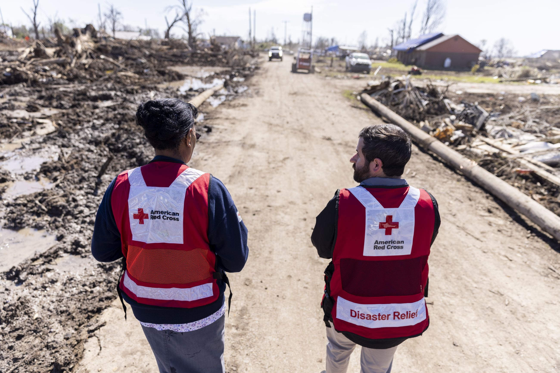 | We’re proud to support @RedCross, helping them respond immediately wherever they are needed.
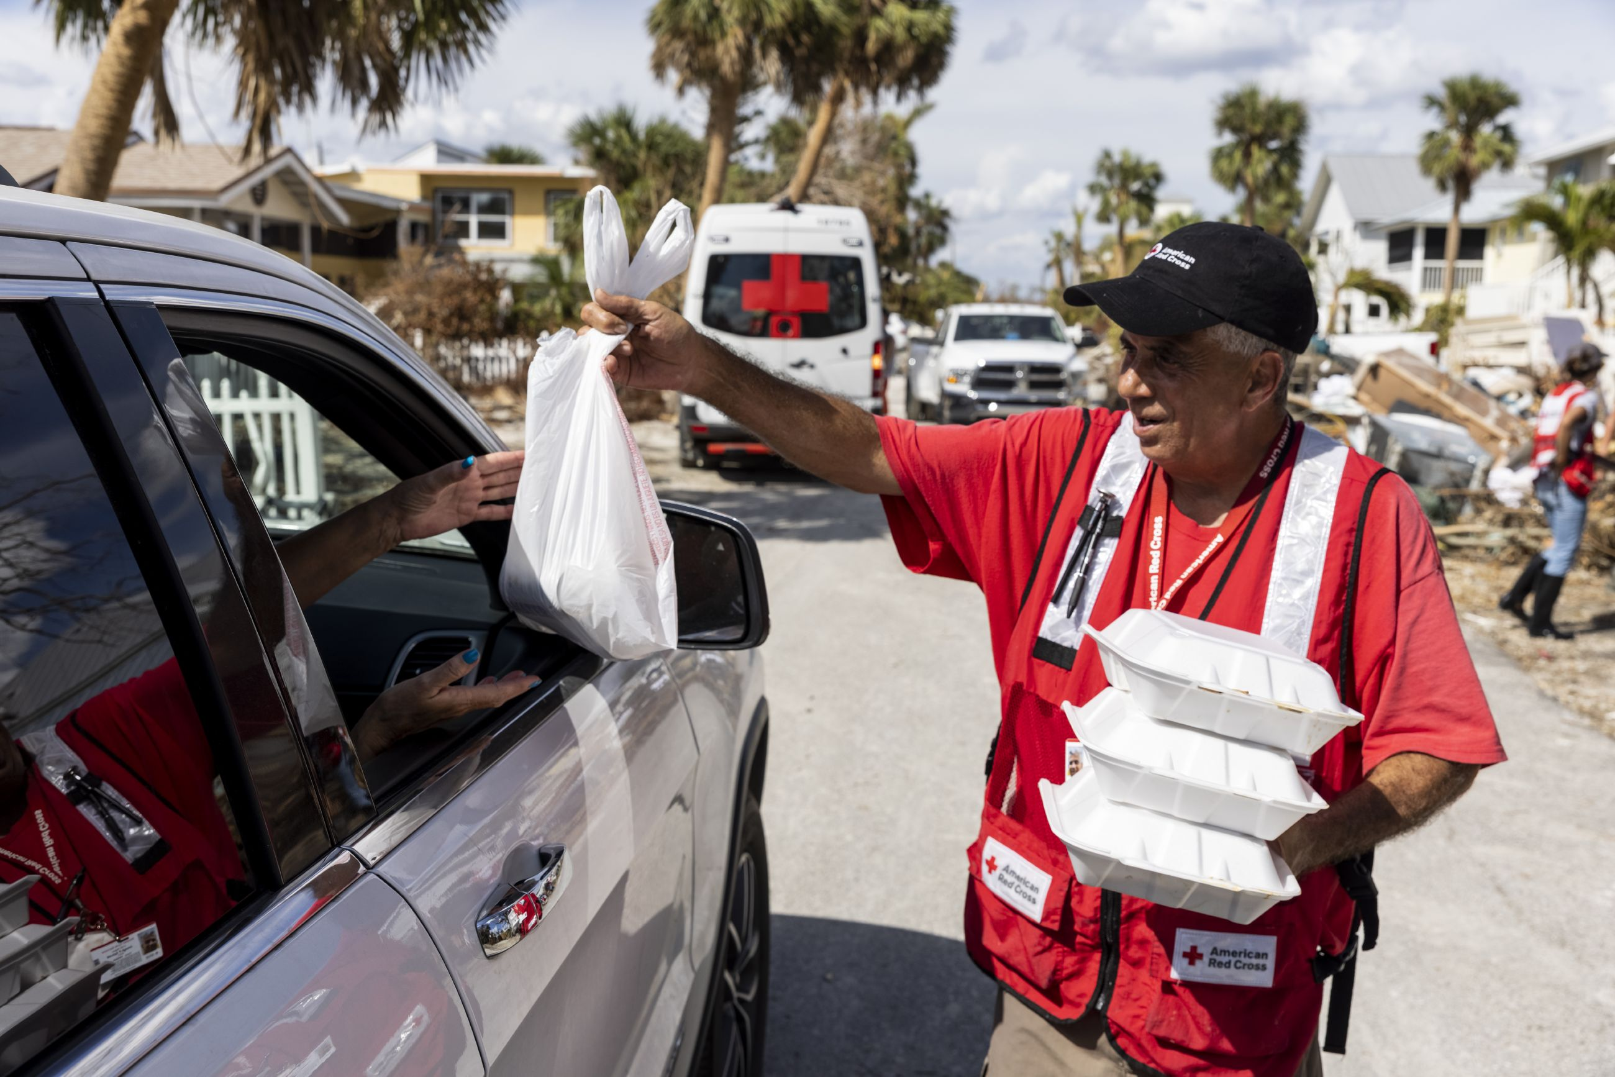 | Did you know that we partner with @RedCross to help _______ in our local community?

- Disaster
Please contact your relationship manager for images from a specific disaster relief operation. | Our thoughts are with the families affected by _____. We are partnering with @RedCross to help.
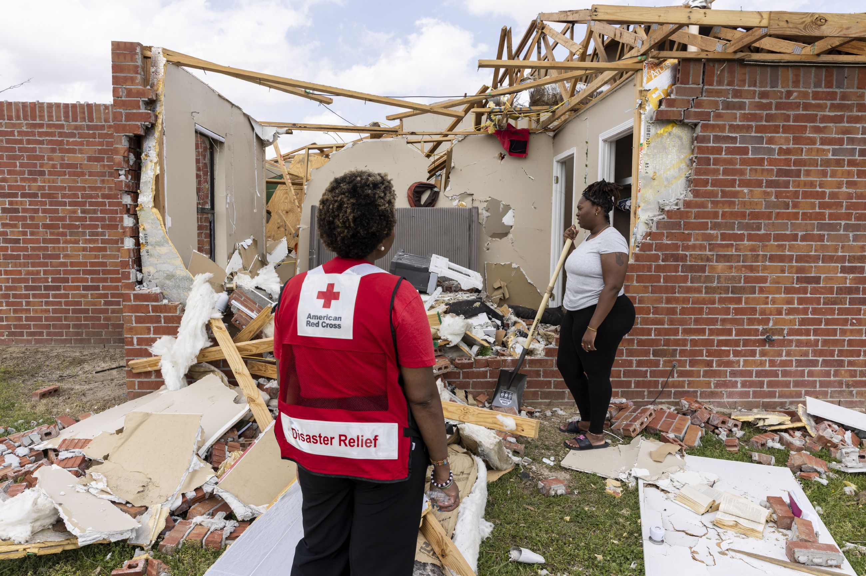 | With our help, @RedCross responds to 60K disasters a year. Join us in helping at redcross.org
 | We’re a @RedCross disaster partner, helping them bring comfort and hope. You can get involved too at redcross.org

- Home Fire Campaign
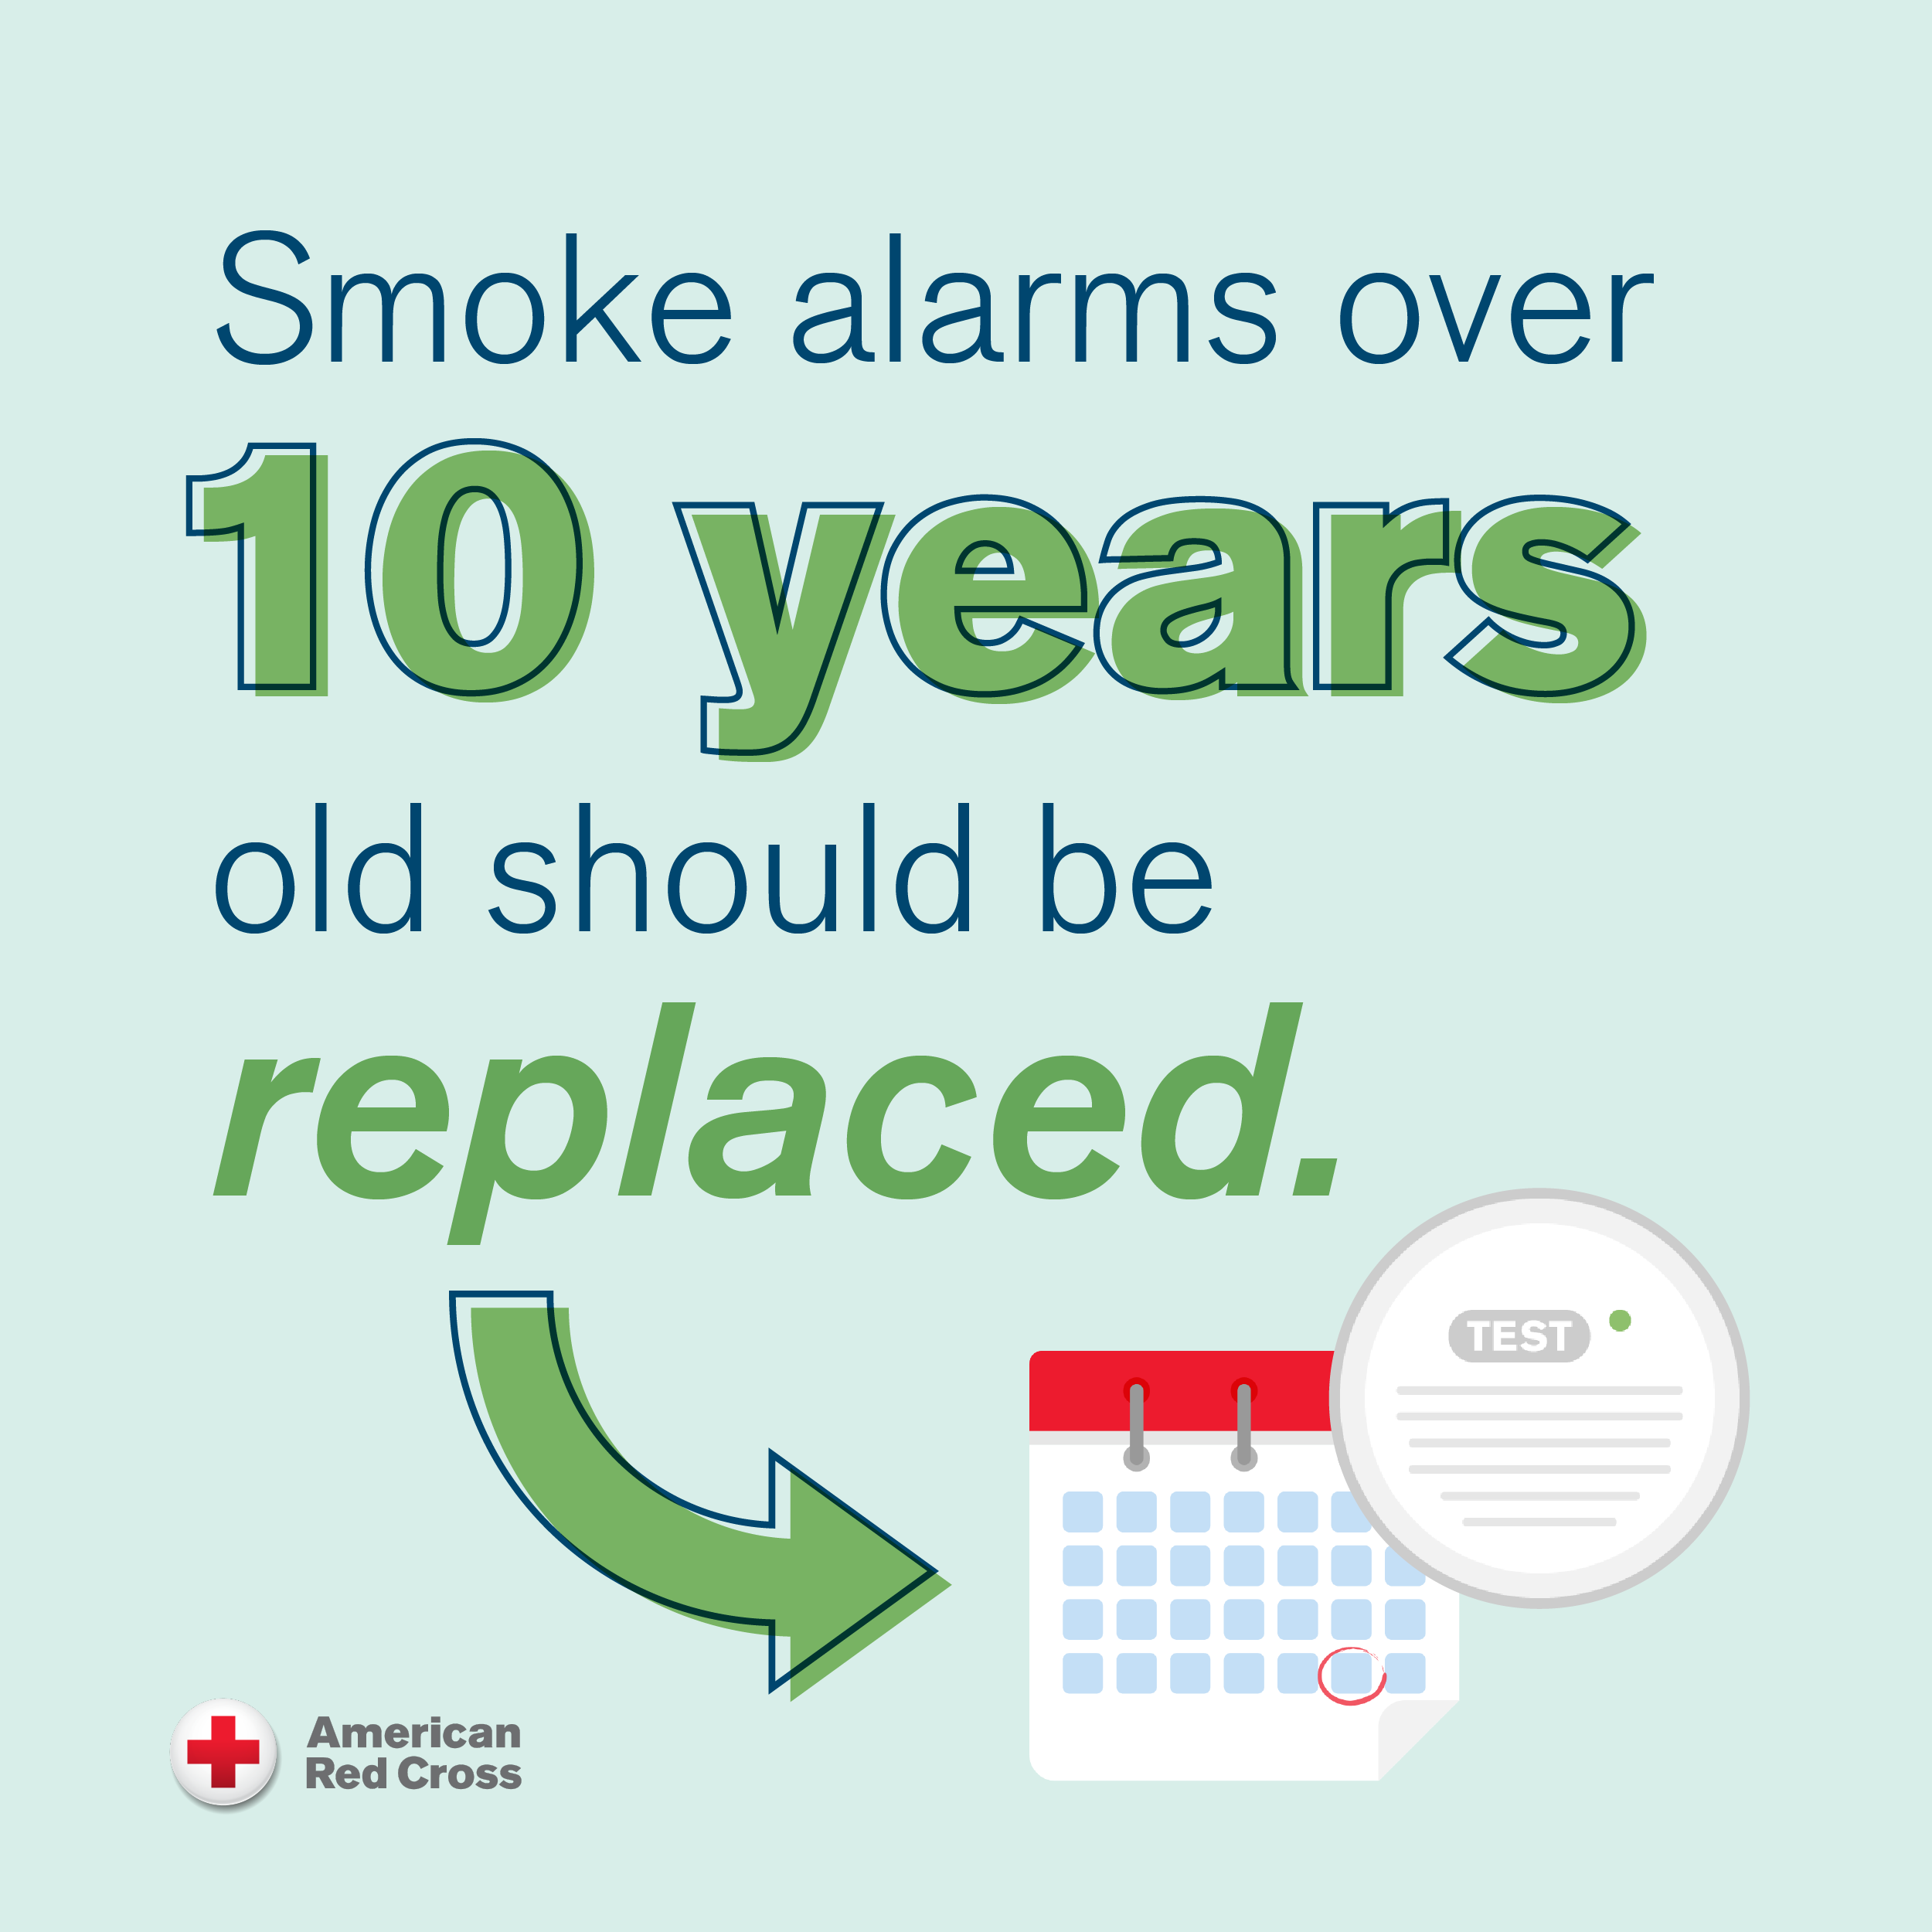 | 7 people die every day from a home fire in the U.S. We’ve partnered with @RedCross to #EndHomeFires. Learn more: redcross.org/homefires
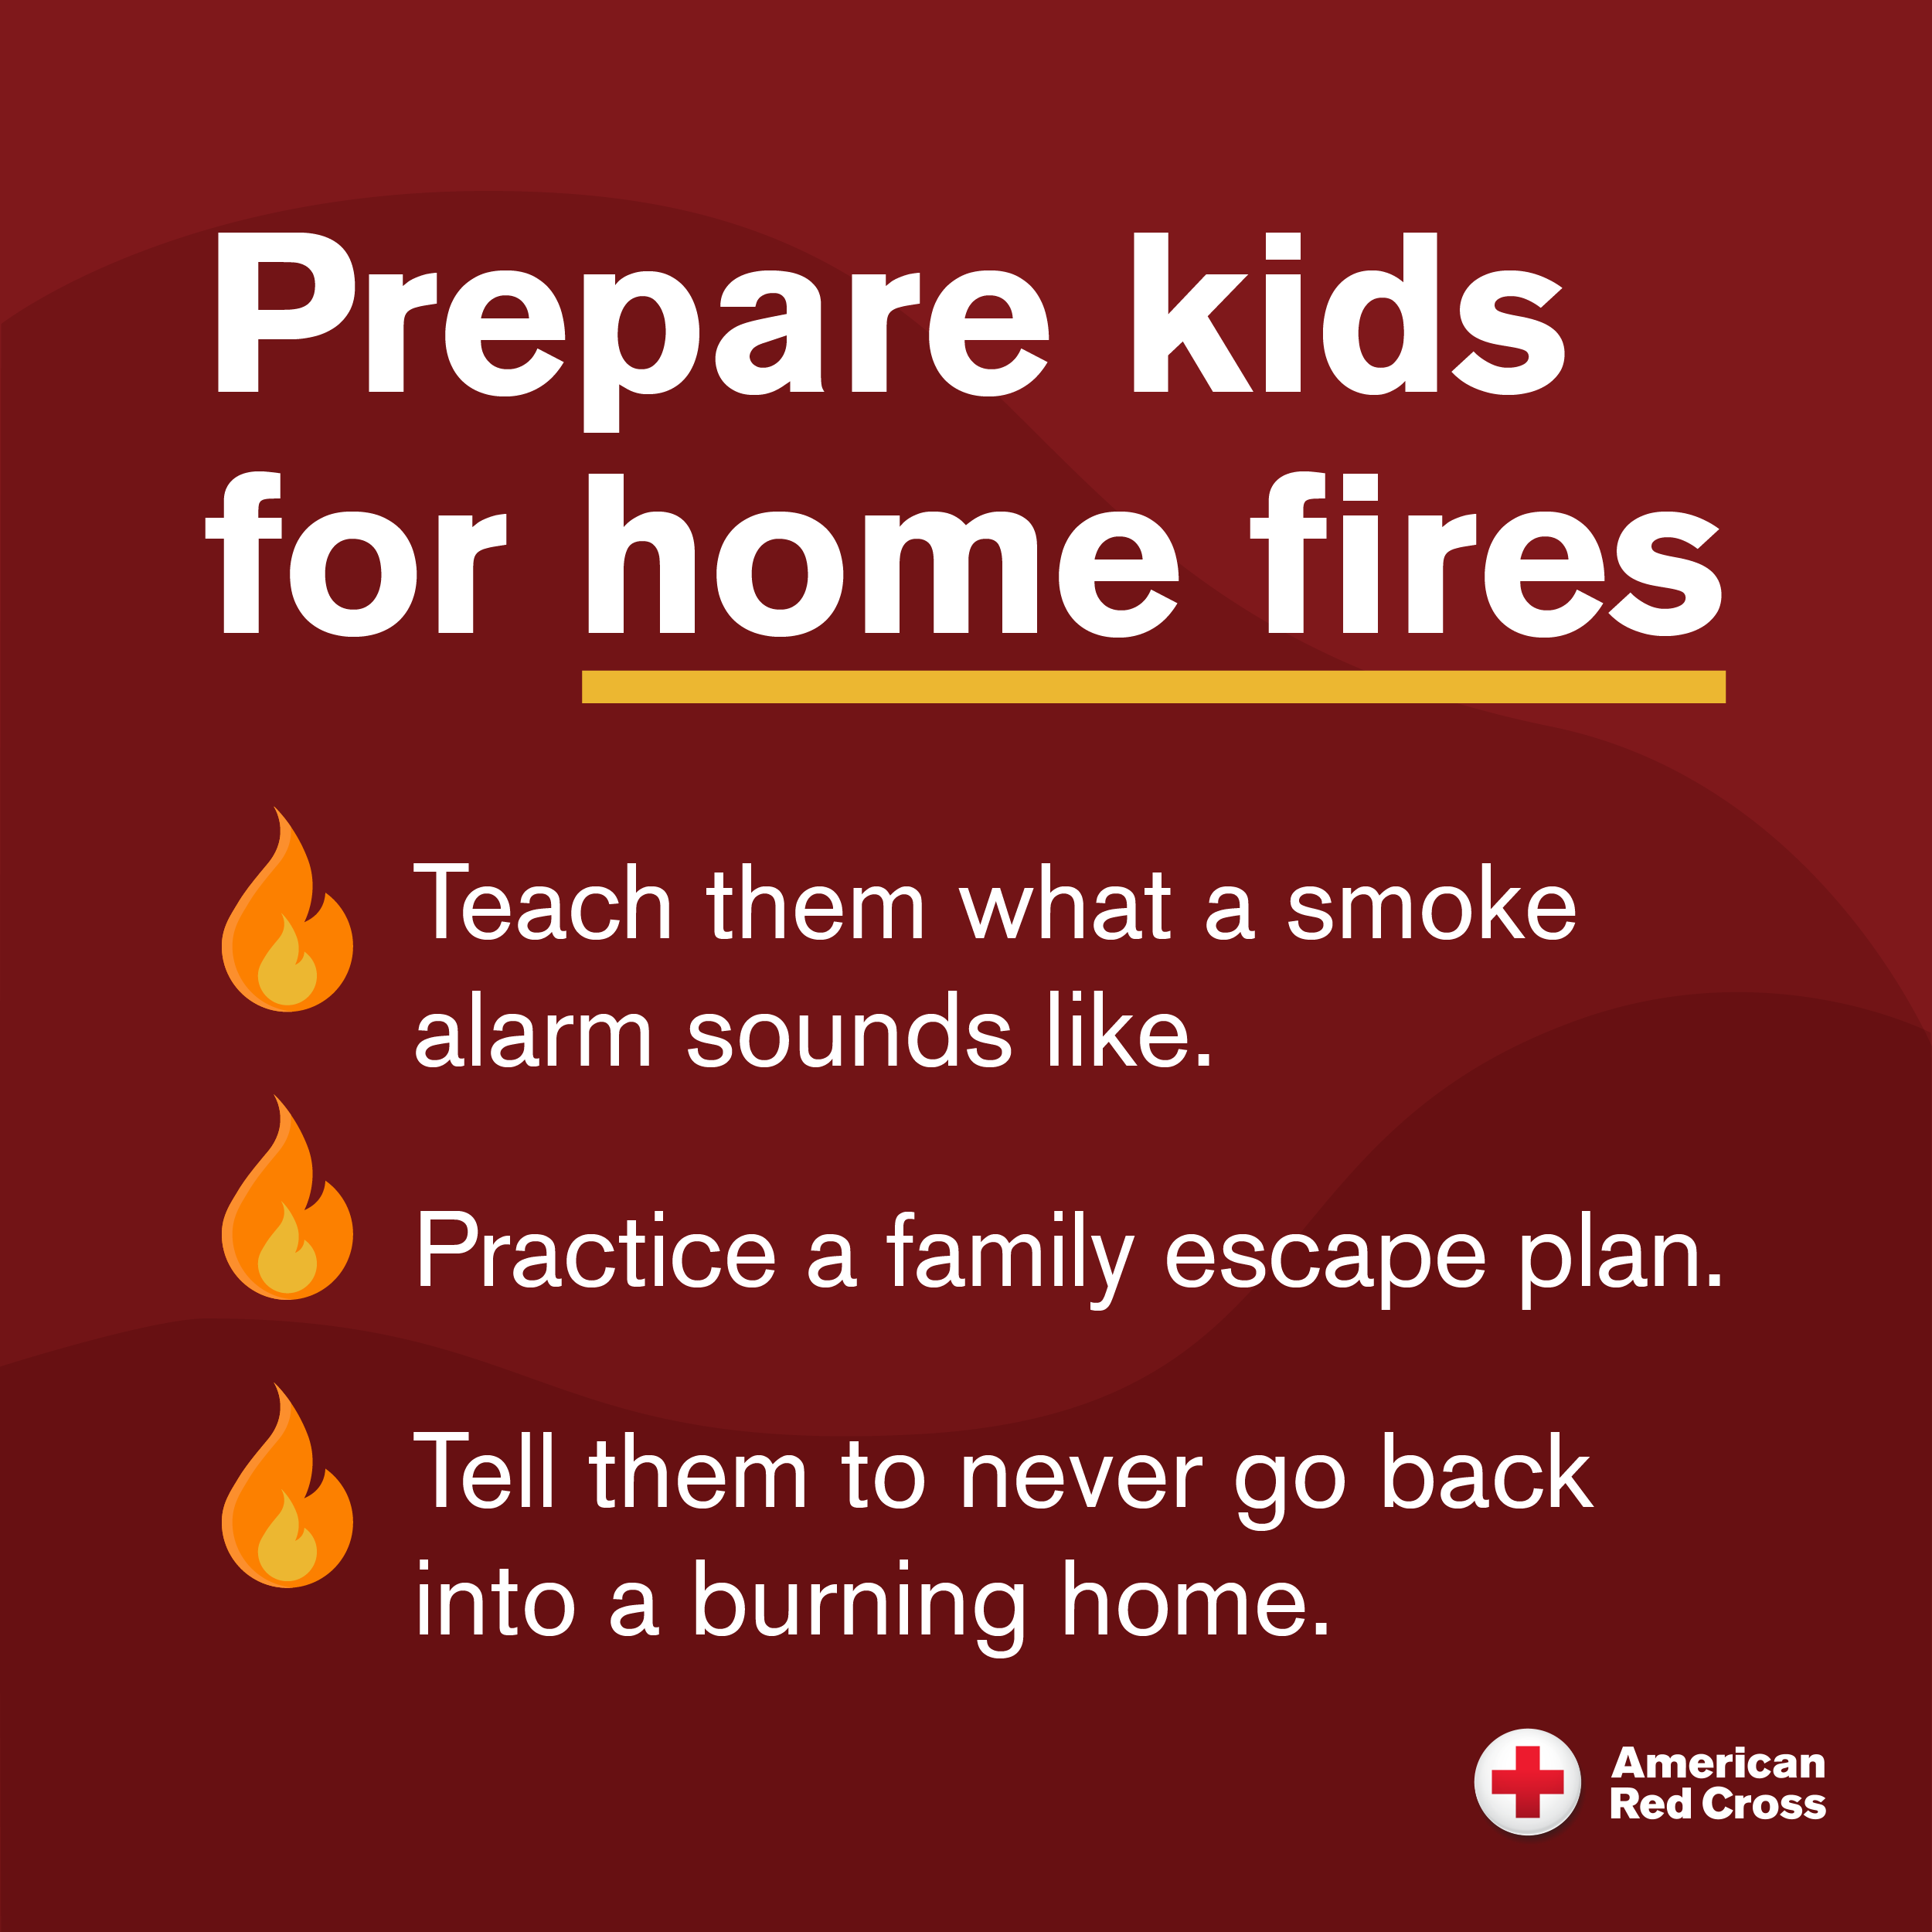 | More lives are lost to home fires than all major disasters combined. We are proud to support @RedCross in their mission to #EndHomeFires.

- Employee Engagement
  - Every 2 seconds someone in America needs blood. (“We”/Company name) hosted a blood drive to help the lifesaving mission of the @RedCross.
  - We are committed to employee education and safety! ___ of our employees participated in a @RedCross Citizen CPR training program.
  - In partnership with @RedCross, ___ of our employees volunteered to ____!

To customize the above X (formerly Twitter) messages for Facebook or Instagram posts, simply use the same messages as the tweets, except with “American Red Cross” written out instead of “@RedCross.”

Suggested Hashtags
- #GiveBloodSaveLives
- #DisasterResponse
- #Preparedness
- #SafetyTips
- #EndHomeFires

Helpful Tips!
- Feel free to add your organization’s personality/language and a personal twist.
- When posting about your involvement with the Red Cross, address how the subject has affected your community and why your organization is involved.
- Include pictures and graphics. Your relationship manager can provide Red Cross images.

Please reach out to your relationship manager with any questions regarding social media strategy or best practices. If you would like, your local Red Cross can follow you on X, Instagram and/or Facebook; please let your Red Cross relationship manager know if you’d like us to do so. Please let us know when you share Red Cross content on your social media pages so we can be sure to engage!

